TAYSIDE MACHINERY LTD
SCOTLAND
TELE: 0044 (0) 1382 200797 FAX: 0044 (0) 1382 202853
e-mail: sales@taysidemachinery.co.uk website: www.taysidemachinery.co.uk

Poreba TR 100B1/6M Heavy Duty Gap Bed Lathe
ST3533

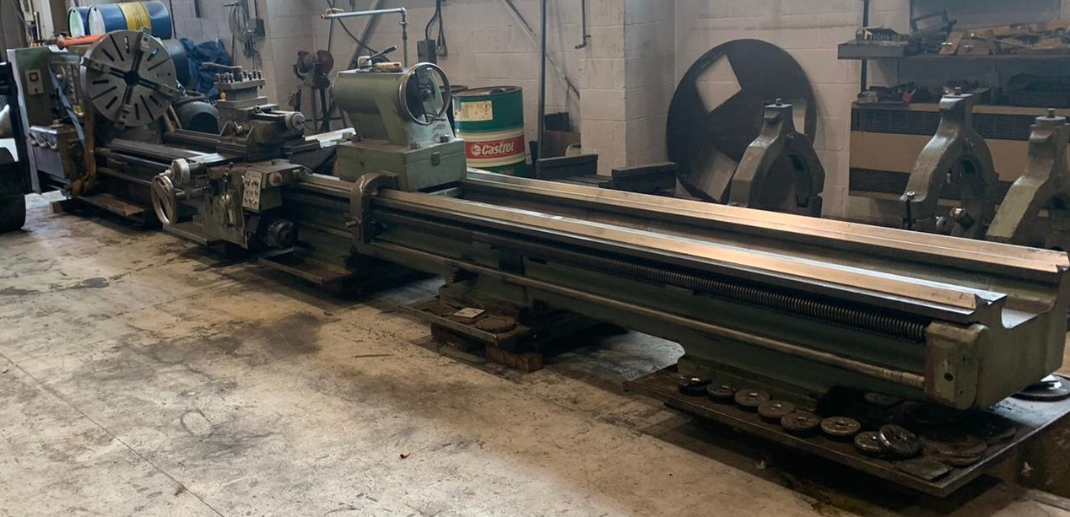

Poreba TR 100B1/6M Heavy Duty Gap Bed Lathe

Model: TR100B1/6M

Swing over Bed: 1000mm
Swing over Cross Slide: 750mm
Swing in Gap: 1350mm
Distance Between Centres: 6000mm

Spindle Bore: 120mm dia.
Spindle Speeds: 5 – 500 RPM

Machine with:
800mm dia. 4 – jaw chuck
Fixed Steady

**photographs taken prior to cleaning and presenting**

